For every if the compiler is checking each statement condition here it is waste of time need to check all the contions

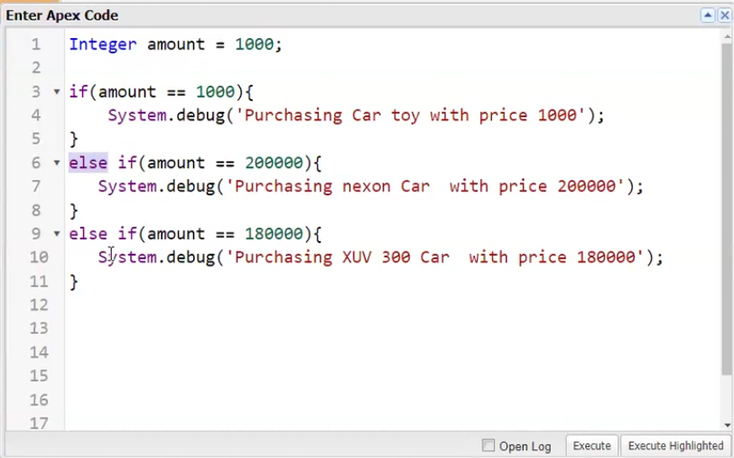

In the above case (else if) means if above if-condition is true don’t come to else-if condition, for example if-condition is false then come to else-if condition here compiler will check based on conditions.

This is error we cannot store like this

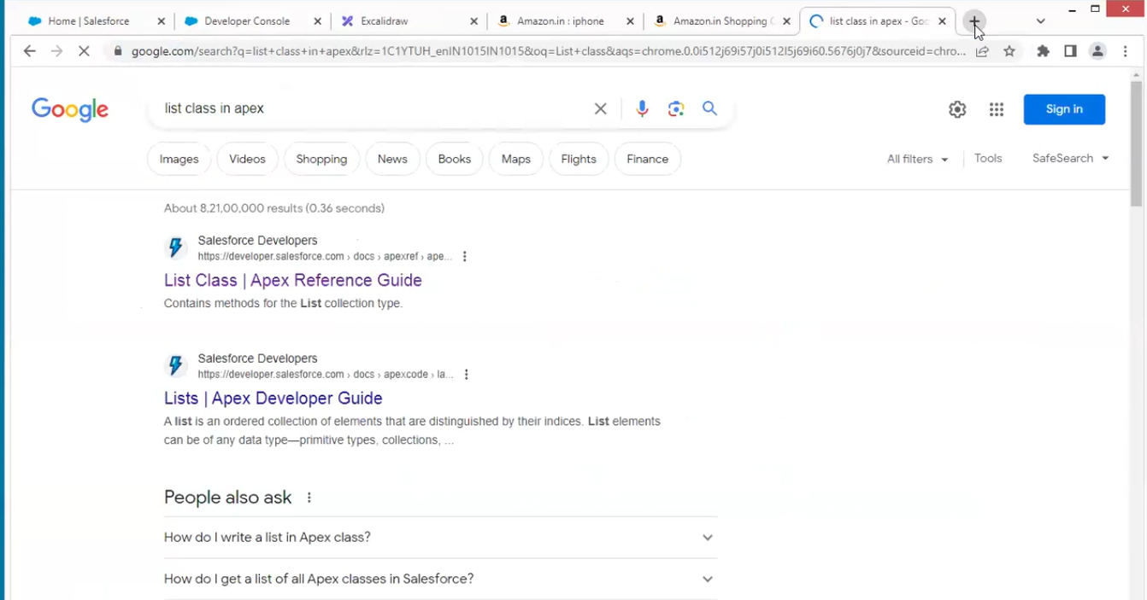

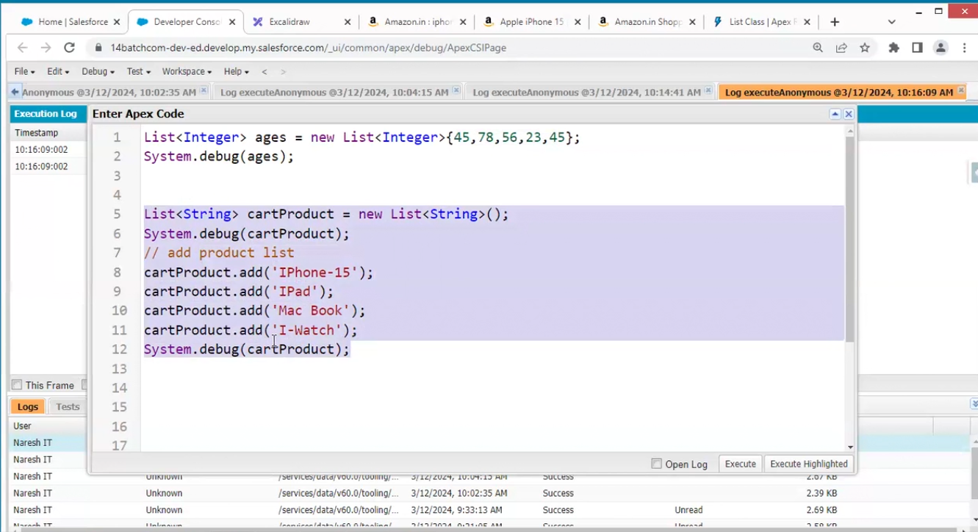

Shit +tab statements align properly

In above to storages are created

With 2 data

Waste of memory to avoid this



